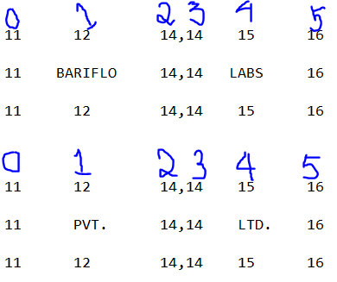

1. **FIRST OCR API PROVIDING US ALL THE WORD BOUNDING VALUES,**
2. **HERE BARIFLO WORD HAS LAST VALUE THAT IS 14, AND 14 IS THE INDEX OF 2.**
3. **LABS WORDS HAS LAST VALUE THAT IS 16, AND 16 IS THE INDEX OF 5.**
4. **NOW THERE IS NO INDEX IS FINDING BY THE OCR. THAT MEANS THERE IS NO WORDS.**
5. **OUTPUT IS LIKE [[ BARIFLO, LABS ], [ PVT. LTD. ]].**